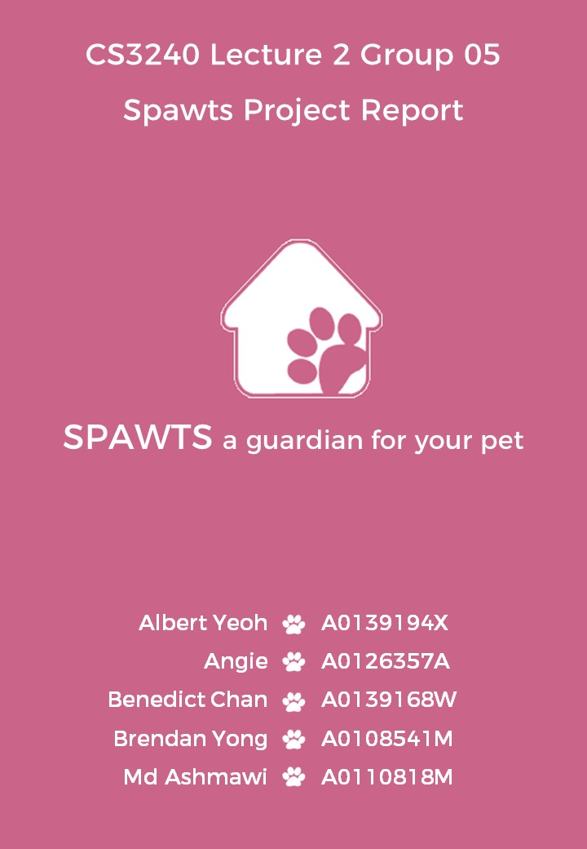

# Problem description

Pet owners are unable to take care of their pets all the time due to certain commitments that may arise unexpectedly. As such, they would require a caretaker for their pets in their absence, normally turning to family members, relatives and friends for help. However, the latter groups may not necessarily be able to help due to their own commitments. These pet owners may then choose to engage pet hotels, though it can be quite costly. Alternatively, they can look for other pet owners at pet community sites, in hopes of finding someone that can fit their busy schedule. Yet most pet owners are unaware of the pet-sitting services offered by other fellow pet owners.

# Proposed solution

A website that connects the members within the pet owner community to accelerate the process of finding a pet-sitter when required, and to raise awareness of pet-sitting services locally. The website will function like a social media platform to entice pet owners to use the web application. This keeps the website active and vibrant, thus appearing more attractive to pet owners seeking solutions to similar issues.

# Defining key tasks

1. Create a profile (owner/pet)
   1. Go into the landing page while logged out
   2. Click on the top right button to login/register
   3. Select the register option
   4. Fill in the form to customise your profile
   5. Click “Submit” to register
2. Create a listing
   1. Click on the “Listings” button on the navigation bar
   2. Click on “Create listing”
   3. Enter your details and information you want the pet-sitter to see
   4. Click “Create!”
3. Find and accept a listing
   1. Click on the “Listings” button on the navigation bar
   2. Click on “View listings”
   3. Select Black Ball’s card (only one that is working)
   4. Read through requirements
   5. Click on “Chat with owner”
   6. Type in “contract” into the chat bar and click send (this is to simulate the owner sending the sitter a contract)
   7. View the contract and accept it

# Description of personas

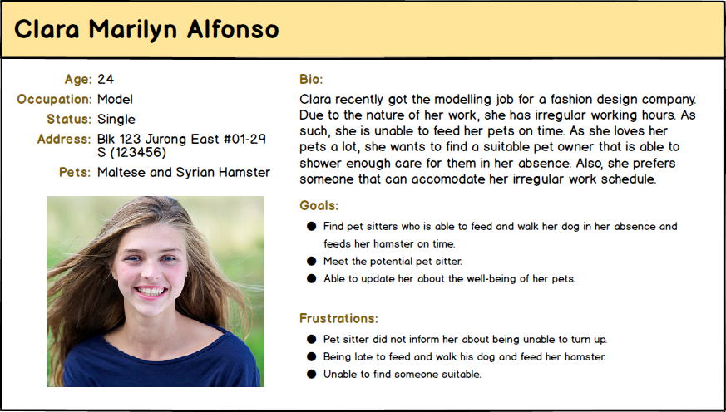

*Persona: A model who has problems taking care of her pet due to irregular working hours*

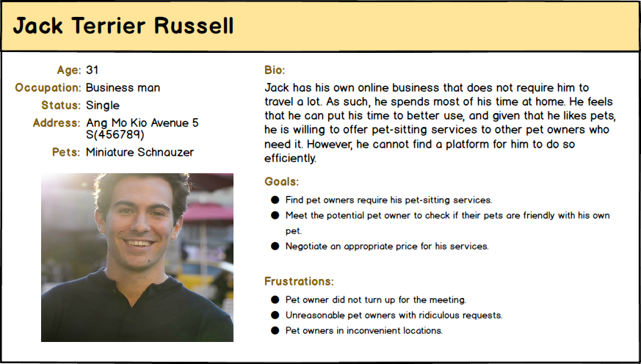

*Persona: An online businessman who is willing to offer his pet-sitting services to those who require it*

# Storyboard

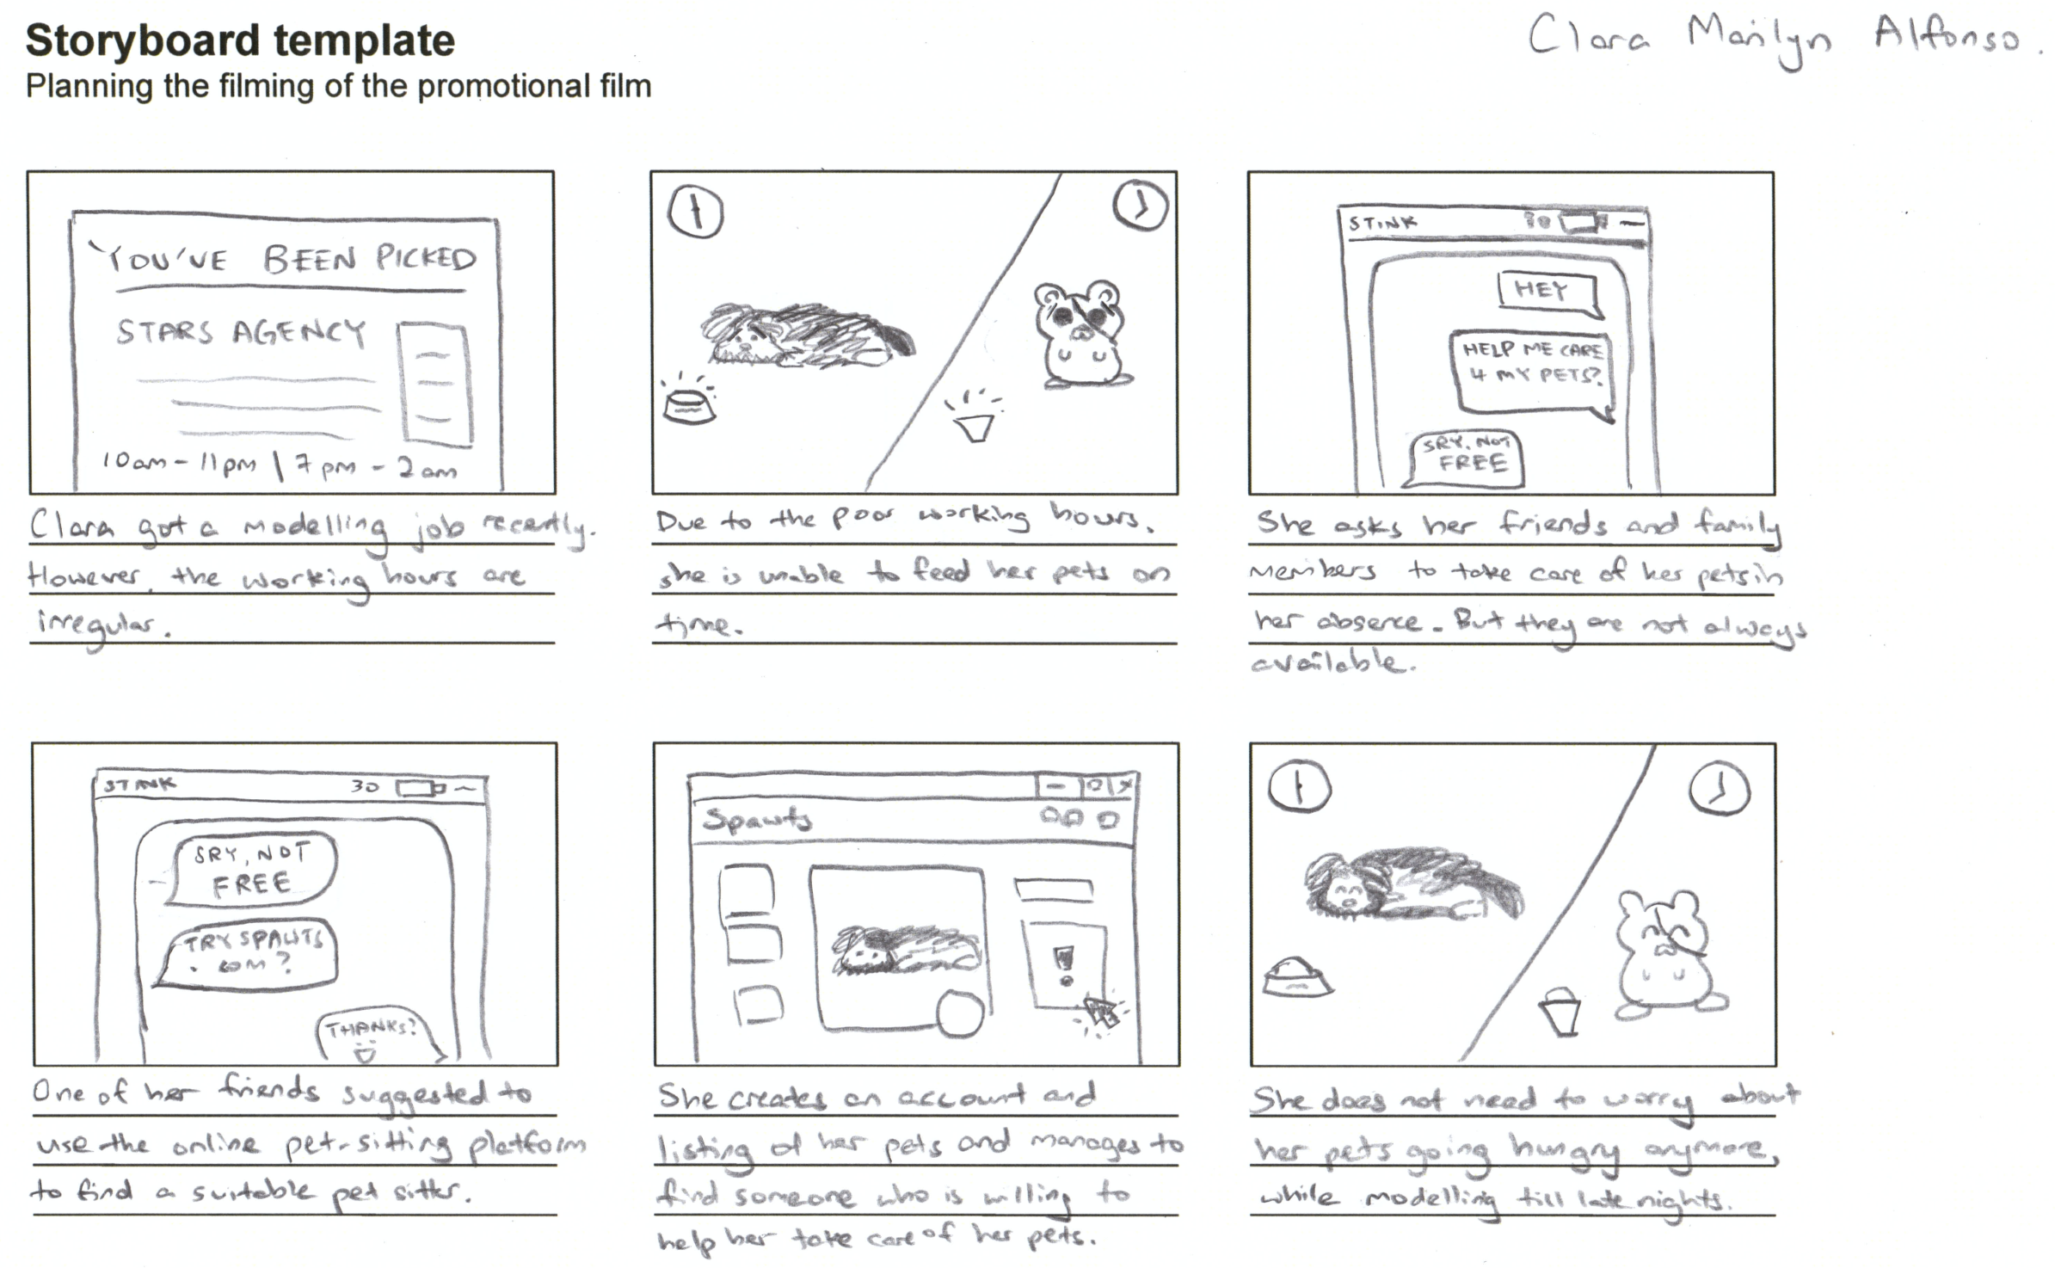

*Storyboard: A pet owner’s process of finding a pet-sitter (ft. Clara)*

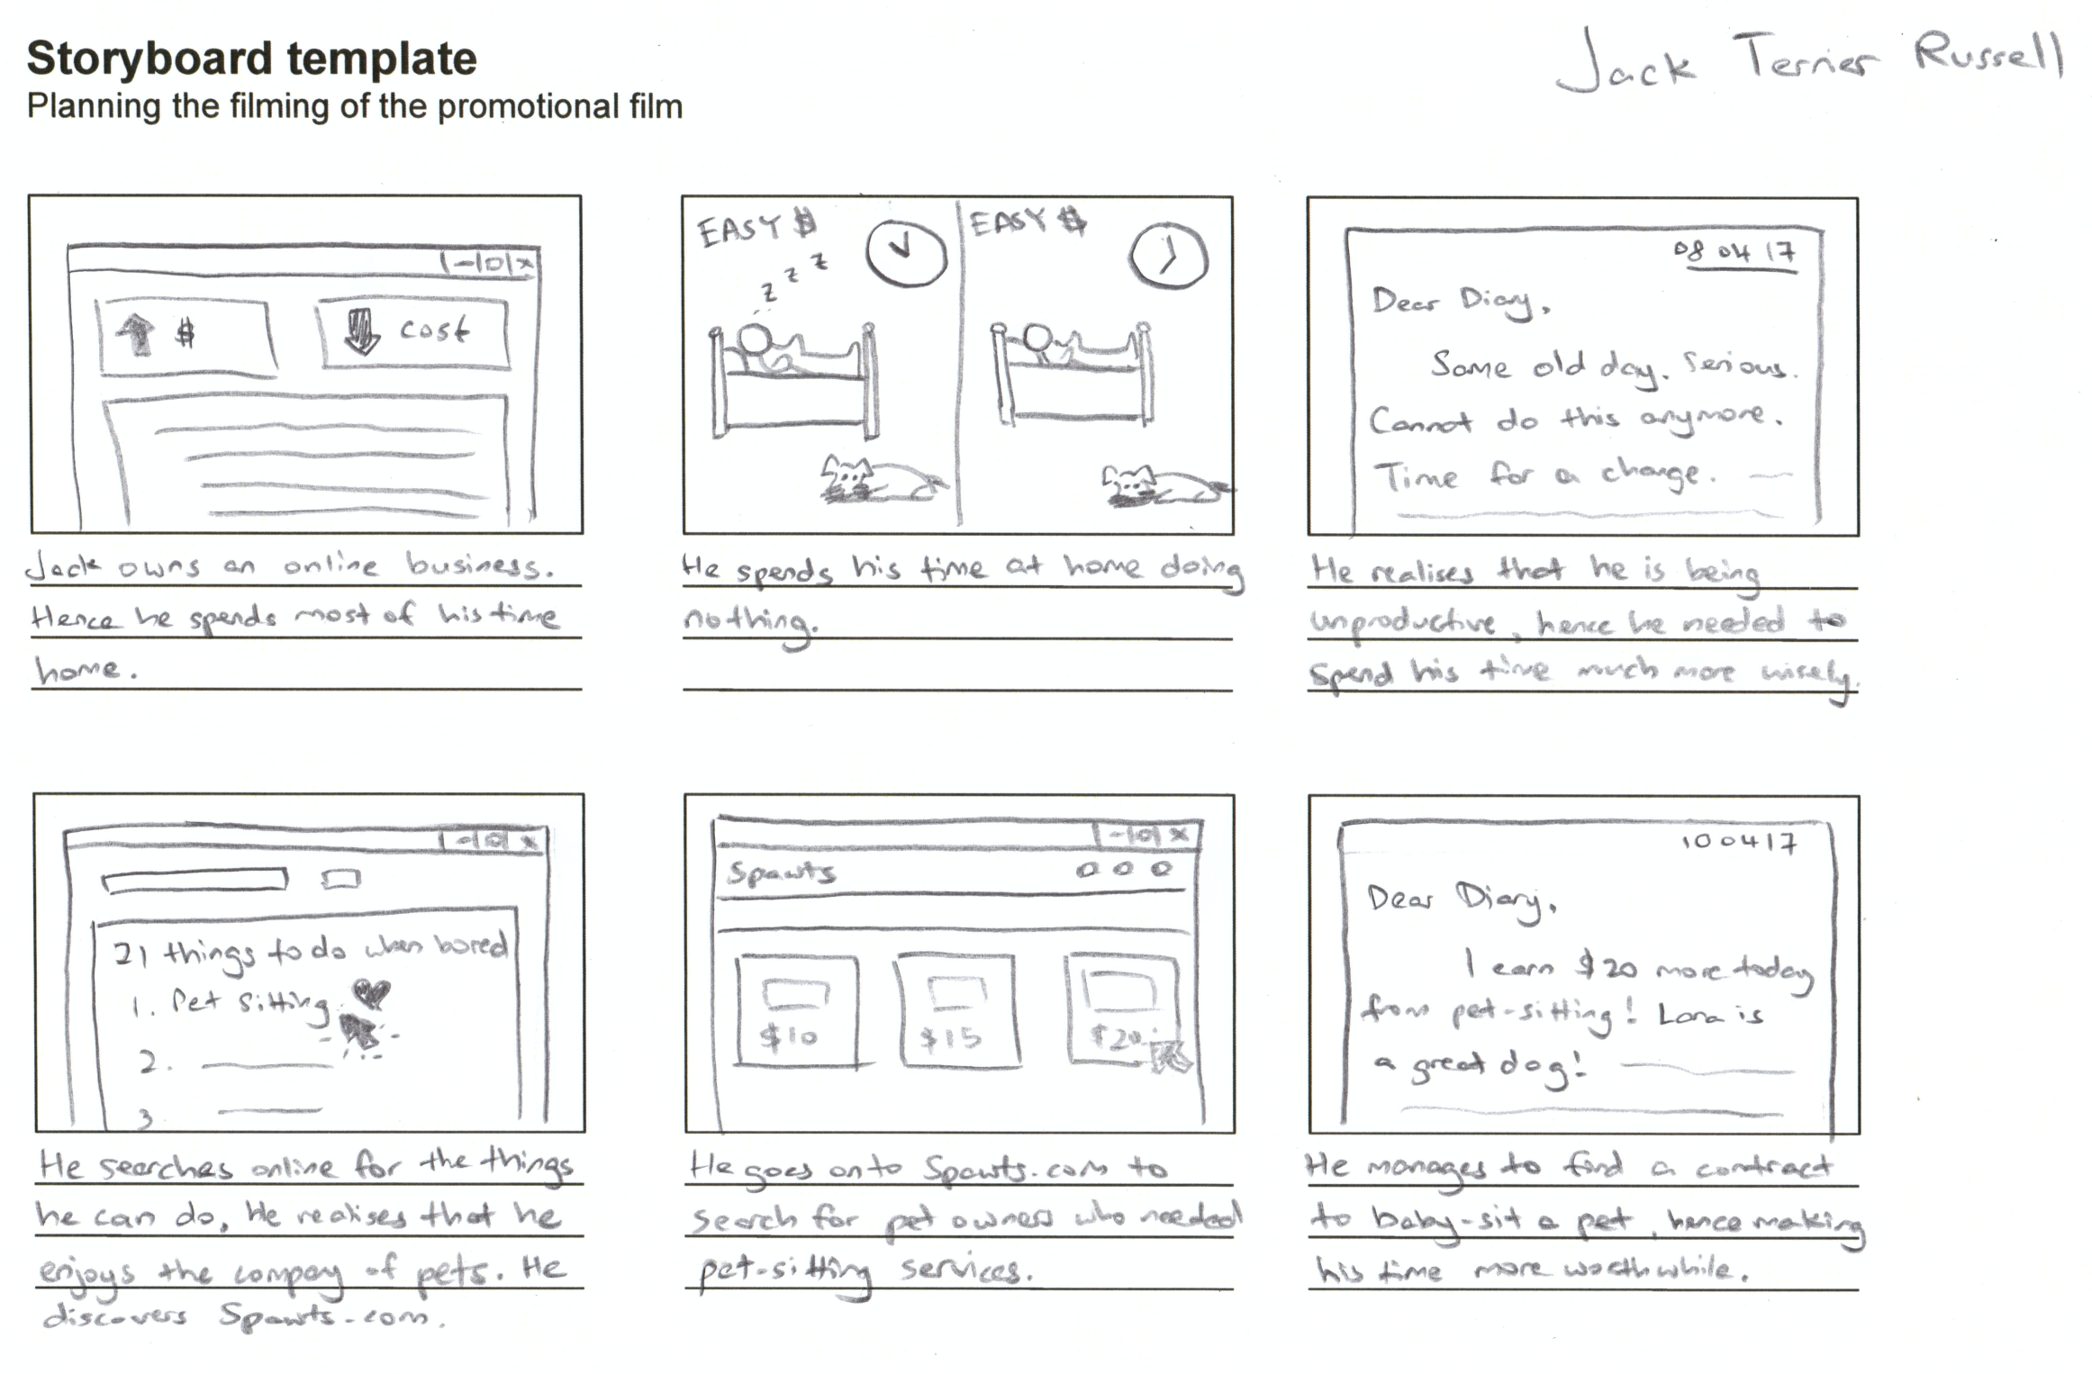

*Storyboard: A pet owner’s process of finding a pet to pet-sit (ft. Jack)*

# Process of development

## Overview

TimelineNew.png

*Image: Overview timeline of process of development*

## Problem ideation

The team went through a brainstorming phase where each member identified a problem that he or she had personally faced or had knowledge of and elaborated on the crux of the problem. Each problem was then reviewed and discussed further. After a process of elimination, we chose the issue of pet owners finding a pet-sitter as our main problem on the conclusion that this was a pressing issue in Singapore.

Creating a solution for this issue has great potential due to the following problems:

* Pet owners tend to look for pet-sitters via newspapers or flyers which can be a hassle to deal with
* Tech savvy pet owners would turn to looking for a pet-sitter online but the information is usually dispersed
* Pet owners seem to find it difficult to look for a pet-sitter when they need the service
* Due to the limited availability of pet-sitters, pet owners usually send their pets to pet hotels which is not cost-effective
* There is no mature platform for pet lovers to interact with one another

## Identify user group

With our main aim on hand, we identified two groups of people who would be most affected by this issue, namely current pet owners and previous pet owners. We considered them as potential users as they are qualified pet owners and pet-sitters who will benefit the most from our product.

We focused on surveying people with experience in owning pets in order to ensure quality feedback. Those without pet-handling experiences were excluded from our user study.

## User study

After identifying our user groups, we conducted a user study in the form of surveys. The questions were generated based on the problems discussed during the ideation process. We designed the surveys to target people who are currently owning or used to own a pet.

You may refer to Survey Results for the survey questions and answers.

### Aim of the user study

Our user study was designed to capture the following information:

* The difficulty faced by a pet owner in finding a pet-sitter for their pets
* The demand for a solution to tackle the difficulty in looking for a pet-sitter
* Whether the existing solutions for the identified problem are effective
* The open-mindedness of the respondents towards the idea of allowing a stranger to take care of their pets
* The open-mindedness of the potential pet-sitters towards the idea of pet-sitting someone else’s pets
* Features the respondents wish to see in our product

### Conclusion of the user study

From the results obtained, as seen in Survey Results, the following conclusions were drawn:

* There is moderate to high difficulty in finding a pet-sitter for pets
* The demand and supply for our solution is present
* Existing solutions, such as pet hotels, are expensive
* Pay expectations of pet-sitters and the amount pet owners are willing to pay for pet-sitting services matched
* The respondents are generally comfortable with strangers caring for their pets, they just require a feedback from the pet-sitter in order to feel assured that their pet is fine while they are away
* Not many respondents have experience in taking care of other people’s pets, but they are open to the idea, both for money and for the enjoyment

### Analysis of the user study

After information gathering, we decided to create a website which serves as a platform for the interaction of our users due to the following reasons:

* Pet owners usually look for pet owners via newspapers or flyers which is rather ineffective as they are easy to misplace and are not real-time
* Technology provides a convenient and efficient platform to reach out to our potential users
* People in Singapore are generally familiar to social media and online shopping websites and therefore have a larger acceptance towards concepts of similar design

On top of that, we did a case study by looking into existing websites that offer pet-sitting services. We split them up into two categories, namely consumer-based services and commercial-based services.

|  |  |
| --- | --- |
| **Consumer-based services** | **Commercial-based services** |
| * Serves as a middleman for pet owners to engage in pet-sitting services * The user experience provided was similar to an online trading site * Users would use it only when they required the services * The user experience was a huge disadvantage as it makes the pet-sitting services mercenary, which is unhealthy for the pet community | * Physical shops that provide services to pet owners * Services offered are often more expensive compared to the consumer-based services * Inconvenient for some pet owners due to the long distance between the pet owner and the shop |

*Table: Comparison and findings on consumer-based services and commercial-based services*

Overall, it is evident that the demand for such a solution is present. Our solution needs to address several pain points, in addition to our core functionalities, which include:

* Security: Making sure that the risk of pet abuse and pet kidnap is brought to a minimum
* Matching a pet-sitter to an owner: Based on location, price preference and etc.

## Develop personas

Based on the survey results we obtained, we drafted out a few personas who possess certain personalities. We then further evaluated each persona draft to see its feasibility by enhancing the necessary details and eliminating the unwanted ones. Additionally, we tried to group similar personas, based on life styles, before summing it up with five different types of personas.

Each team member handled one type of persona. We looked through our survey results and researched on the internet on the needs and wants of each type. After that, we gave each of our persona attributes to properly define its role in society and its impact on the problem we are currently trying to resolve.

However, for the prototype, we will only be using 2 out of the 5 potential users as we felt that it is ample for demonstration purposes of the web application. Refer to the Appendix for other personas.

## Solution ideation / Storyboarding

Now that we know what users wanted and who the users are, we brainstormed and discussed the best way to address the problem. The decision was made to treat the website as a social media site with a way for owners to find sitters for hire. Storyboards were created to better understand and empathise what a user may need or face when using our solution. From here, we defined our 3 main key tasks.

## Task design

### Motivations of the tasks

#### Task 1: Create a profile (owner/pet)

Firstly, we recognise that our user groups need to be represented on the platform in order to match them with a pet-sitter easily. We evaluated many social media platforms, such as Facebook and Instagram, to find out the reasons behind their popularity.

We discovered the following findings:

* The active user base and the idea of real-time status updates are the driving forces that attracted users to use and to keep using the platforms
* Having an online presence or representation allows for information to be readily available to an interested pet-sitter and allows for the owner to be seen by people who are looking
* Having an online representation of oneself helps display the human authenticity. Other people will be more comfortable with a user that is transparent about his pet care or someone who has received good reviews

As such, we decided that our first task would be the creation of a profile, which is similar to a social media platform profile page, in order to reap the advantages of the system. Having a page which is similar to an existing profile also increases the learnability and familiarity of the users, according to the Design Principles.

We also thought that it would be necessary for pets to have a separate profiles from their owners. This is to address the aforementioned security issue, whereby the pet owners wish to be able to receive updates regarding their pets whenever they are not around. With a separate pet profile, pet-sitters may tag photos and videos of the pet that they are currently pet-sitting and the pet owners will be updated with the news of their pets, putting them at ease.

#### Task 2: Create a listing

Secondly, our user groups also need to be able to specify information that is specific to the pets they own. This is important for both parties as understanding the needs of the pet can be a major factor in determining whether the pet-sitter is suitable or not.

Therefore, we considered the following factors:

* Pet owners need to be able to show information specific to their pets or to a particular job. As pets can fall ill or age, the solution needs to be versatile enough for the owner to disclose information
* There is a need to implement a process for the owner to input these information which will then be publicly available for others to see

These bring us to our second task, creating a listing. A listing is where pet-sitters may view the description left by the pet owners regarding a specific job posted.

#### Task 3: Find and accept a listing

Lastly, in order to find a listing, our user groups need to be able to view information on all the listings available and pick one that they are comfortable with.

We have arranged a few considerations regarding this task:

* There may be a large amount of listings available, thus a way to compare and view multiple summarised listings may be necessary
* More information on a chosen listing needs to be available on demand with a way to contact the owner for more information
* There also needs to be some form of security or assurance in closing a deal

With these considerations in mind, we visited several websites with listings and found out that the best way to display a large amount of data with photos is via thumbnails. We have also included a search bar which will increase the efficiency of the searching process.

In addition, to provide a sense of assurance to both parties, we will be supporting a chat system for the pet-sitter to contact the pet owner after he has chosen a particular listing. This is to facilitate negotiation between the pet owner and pet-sitters and let them find out more about each other’s conditions before engaging in a provider-consumer relationship. Furthermore, to provide a sense of security, we thought of binding both parties to a contract generated based on the listing description. Both the pet owner and pet-sitter have to accept the agreement for the bond to be effective.

### Metrics

* Time taken: To evaluate the ease of users in completing the key tasks
* Number of clicks on things irrelevant to the task: To evaluate the flow of our prototype in doing the tasks, more irrelevant clicks would mean that users were confused on how to perform the task
* Number of clicks on non-clickable elements: We want to investigate the affordance of our website. (This does not take into account, clickable but unimplemented elements)
* Level of assurance after the completion of a task: After the completion of the task, we survey how sure they felt after completing key actions
  + After creating the profile/creating a listing, whether the users felt that the forms were sufficient
  + After viewing a listing, if the users felt that they have enough information to decide to take a job
* With all these requirements to fulfil, we designed tasks to evaluate if our prototypes address the pain points of the users.

## Iterative prototyping

For our preliminary prototypes, we decided to prototype each of the different main tasks. We used wire-framing tools like Balsamiq and sketches to quickly bounce off ideas with each other and did some quick and dirty testing before we created a higher-fidelity prototype. We went through the process of brainstorming and testing several times.

You may find the preliminary prototypes and evaluations in Deliverable 3 Prototypes.

After all the information and feedback gathered, we have combined our prototypes and linked them together to produce our final prototype.

Technology-wise, we chose to use HTML5, paired with Bootstrap and jQuery, in order to give a better feel and interaction of how the solution will be. Deploying on these frameworks also allow us better control on aesthetics and more precise control over micro-interactions. Doing this in higher-fidelity will allow us to conduct usability testing better compared to a lower-fidelity one.

# Final prototype usability testing

We tested each prototype with the target audience by specifying a task for them to do, and asking them to think-aloud (formative) while navigating the prototype. We then recorded the details via note taking, and interviewed them about their overall impression as a form of summative evaluation.

In between iterations of the final prototype, we also did some quick and dirty testing with the target audience to gain quick insights and correct/improve the prototype faster. We use A/B testing for some prototypes in between iterations too to achieve the same effect as quick and dirty.

We also wanted to test non-key tasks like the navbar icons popping out additional options when clicked. Feedbacks for these aspects were to help us in future developments of the product.

You may find our final prototype at Final Prototype. The starting page is mainpage-loggedout.html.

## Task 1: Create a profile (owner/pet)

*Open task: You are in need of someone to look after your pets. You found out from a friend about a website, Spawts, which can help you find a pet-sitter. Explore the website to see if its basic functions can fit your need.*

This task is intentionally open to see if a user who chances upon the site will be willing to register an account (which requires creating a profile) to use the platform. The test will end once the testee finishes creating a profile.

## Task 2: Create a listing

*Direct task: Navigate the site to create a job listing, to ask someone to take care of your pet bird for a week.*

We want to investigate the ease of completing this task. We also want to see the flow of actions the user takes to complete this task.

## Task 3: Find and accept a listing

*Scenario task: You are a university student, in the midst of your holidays. In your boredom, you decide to check Spawts to find jobs that you can take, so as to earn a quick buck and enjoy yourself. Sadly, your parents do not allow you to keep a large pet in the house. Use Spawts to find the perfect job for you to take.*

We created a scenario based on our user personas, then asked the user to complete the task while making decisions based on the scenario criteria. This helps us understand what goes through the pet-sitter’s mind when taking up jobs.

## Major findings from usability testing

### Task 1: Create a profile (owner/pet)

* There is not enough prompts for new users who chance upon the site to register an account
  + They cannot immediately tell the purpose of registering an account
* The site does not tell the user why it needs their email address on registration
* There is no prompt for users to create their profiles

### Task 2: Create a listing

* The word ‘listing’ was not obvious enough to users of what it meant
  + Some suggestions include ‘job’ and ‘request’
* The form to create a listing does not have a good flow
  + There could have been prompts like “This field has not been filled up” to guide the user along
* There should be an option for other pet species than the ones already stated

Task 3: Find and accept a listing

* The layout is similar to Carousell and therefore is quite appealing and familiar
* There could be better search options available for users
  + Some suggestions include searching by a range of dates or range of prices
* It is not obvious for users how to accept the job listing
* It might be necessary to have a tutorial page to educate users on the process of accepting a job listing
* Layering the data shown to the users is helpful
  + Showing more important information in the form of cards when viewing of multiple cards at a time, and then showing more information on a dedicated job listing page helps to layer information flow to the user
* There was a need to simulate a contract being sent to the pet-sitter
  + This was confusing to some users as they get stuck, and we had to input the command to trigger the simulation
* The contract was a good idea as it helps to reassure both the pet owners and pet-sitters

Overall

* Simple and easy-on-the-eyes colour theme
* Interesting addition to a “make-and-take-requests” kind of platform with the social media aspect
* Easy to know what user can interact with
* Flow guides the user
* The tasks in itself were largely successful in getting the job done

# Final prototype adjustments

|  |  |
| --- | --- |
| **Adjustments to be made** | **Reasons for adjustment** |
| Add pop-ups to direct new users to key task flows | Our website which hinges on the social media aspect, should be as direct as possible in encouraging users to create a profile, etc. |
| Add a review button on the individual listing after the contract ends | This is to allow feedback and transparency to all users, and for future pet-sitters to make a more informed decision. |
| Buttons in the listings page can show more affordance | Overlay an image of a magnifying glass over the image of the individual cards to better show its a button. |
| Better recovery models for our forms | A confirmation screen could be useful for users in the field-heavy profile and listing creation pages. Editing fields could be more dynamic, to allow quick changes by the users. |
| A negotiation form in the listing contract | Instead of leaving the discussion of the job details to chat, we could implement a negotiation feature, for potential job-takers to negotiate more easily with the clients. |

*Table: Adjustments to be made on the final prototype and the corresponding reasons*

# Key ideas of Interactive Design

1. Nielson’s design principles:

* Consistency
  + Fonts, buttons, icons are standardised
  + Standardised navbar
  + Standardised colour scheme
  + The same actions and links can be achieved through the standardised navbar
* Familiarity
  + Layout similar to social media platforms as well as online marketplaces
  + Icons used are similar to those used in social media platforms
* Affordance
  + Interactable elements that look interactive
  + Icons indicate its function through familiarity (eg. text box icon for messages, bell icon for notifications, person icon for profiles)
* Visibility
  + Hiding elements until they are needed eg. Chatbox, reviews, etc.
  + Navbar elements expand to show more options
  + Broke up large pieces of information into defined areas so that information is broken down and more digestible
* Feedback
  + Clickable elements react to mouse input, eg: opacity change, colour change, etc.
  + State changes when buttons are hovered/clicked
* Constraints
  + Showing information of listing bit by bit instead of listing full details of each job
  + User has to login before accessing the site’s features
* Recovery
  + Button to allow to edit listing after publishing
  + Links in navbar always allow the user to find a way out of a page
* Design dialogue to yield closure
  + Creating profiles for owner or pet or creating listing ends with showing the created profile or listing, to show the user what they have created.
  + Finding and accepting a listing ends with a green button saying contract accepted

1. Aesthetics and Minimalist Design

* Clean and simple webpages
* Tried to have as much whitespace as possible although the nature of the solution requires a lot of information to be shown. Hence we tried to break down the information to bite sized pieces that lead the user as the user discovers more

1. Taking advantage of conventions

* We followed the widely accepted conventions of profile pages in social media and extended these conventions to the pet profiles as well.
* Some of these conventions include using widely recognizable icons, such as the bell icon for notifications, big clear words for buttons, and placing the logo, which leads back to the homepage upon clicking, at the top left hand corner of the page within the navigation bar

1. Creating a clear visual hierarchy

* The navigation bar is maintained throughout all the pages, with the same icons and style
* Actions that can be carried out are grouped into logos at the right section of the top navigation bar before and after logging in
* The logo on the left section of the top navigation bar leads back to the homepage, and clearly indicates the name of the website

1. Break pages up into clearly defined areas

* The pink colour of the navigation bar at the top of the page clearly differentiates it from the other sections within the same page
* The navigation bar is maintained throughout all the pages, with the same icons and style, so as to allow users quick access to other actions and pages if needed
* Other sections within the page are defined within rounded boxes, to separate the information into smaller groups
* For example, the create pages for owner’s profile, pet’s profile and listing, have a clear box defining the form to be filled, and within the form there are more text boxes with sub headings and placeholders to indicate what content to input as well as the proper format for the input

1. Make obvious what is clickable

* Actions and links which can be clicked are defined within icons and rounded boxes of colours different from the selected pink background

1. Go on a content diet

* Content to be displayed is kept to a minimum as much as possible, unless the situation or action executed calls for it
* For instance, the homepage displays the navigation bar and a background picture with a simple caption and a button with the words “Find Out More”. Clicking the find out more button would lead the user to view news and other information further below within the same page. This information would be grouped within boxes with a quick description of the topic at hand, and a button that says “Read More”. This allows the user to have a gist of what the featured news is about without overloading them, and should they want to find out more, the user can then click the button and be redirected to a page containing more details
* The create pages for the owner’s profile, pet profile, and listing, will need details to be input by the user. We have created the forms such that it is as simple as possible, with clear headings and text boxes for the user to input, so that the user will not be overwhelmed or lost as to what to do
* The profile and listing pages require details to be displayed for the user’s own knowledge. As such, these pages were designed in such a way that the necessary details are grouped together and easily accessed

1. Reduce cognitive load

* Corresponding with the concept of familiarity, icons used to define the actions and links are straightforward and easy to recognise. For example, the message box is defined by the text box icon, notifications are defined by the bell icon, and profiles are defined by the character icon. This would help to reduce cognitive load as users are able to identify what the icons represent based no familiarity
* Pages, namely the create pages for the owner’s profile, pet profile, and listing, which require information are designed to be as simple and straightforward as possible. For these pages, we focused on a more simple and straightforward design. The forms that need to be filled are defined by a clear box, and within the box itself there are more text boxes with clear sub headings and placeholders to indicate what content to input as well as the proper format for the input. This is to allow the users to be able to understand what information is required and where to input the corresponding details, without thinking too much
* Actions and links are defined clearly by name. The links lead directly to the pages of the same name as its link, so as not to confuse the user

1. Design navigation

* As mentioned earlier, the presence of the same navigation bar at the same location within all the pages allows the user quick and convenient access throughout the website.

# Appendix

The survey results, storyboards and personas can be found in the “Appendix” folder. It also includes all previous prototypes, personas and storyboards.